-Storing relative pathnames to data sources

File -> Map Document Properties

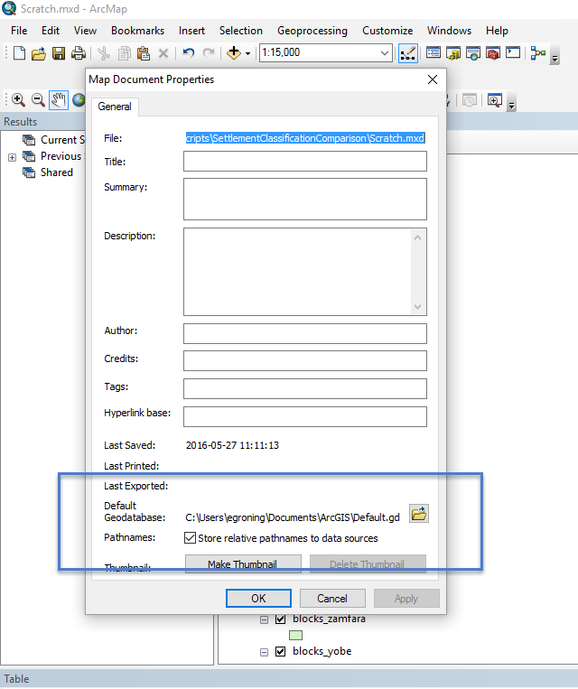

Labeling raster points

Change shape to square

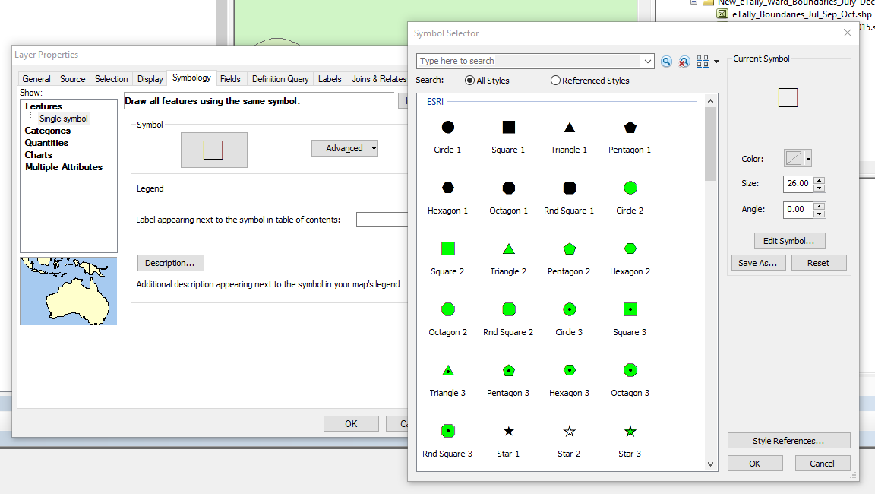

Set reference scale once happy with square size / label size

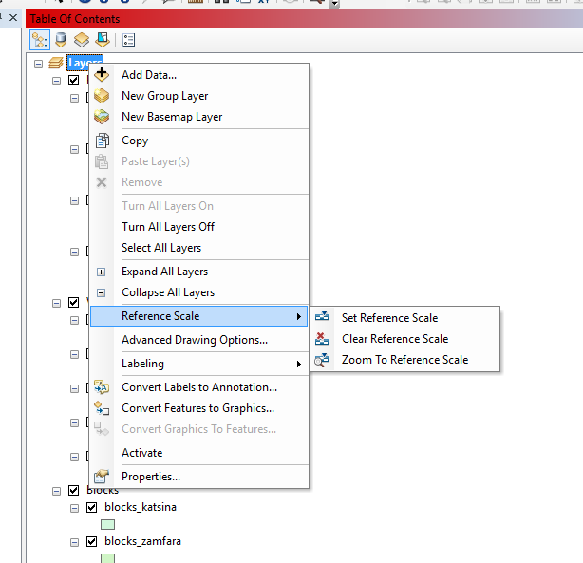

Add label, play with offsets if need to show multiple

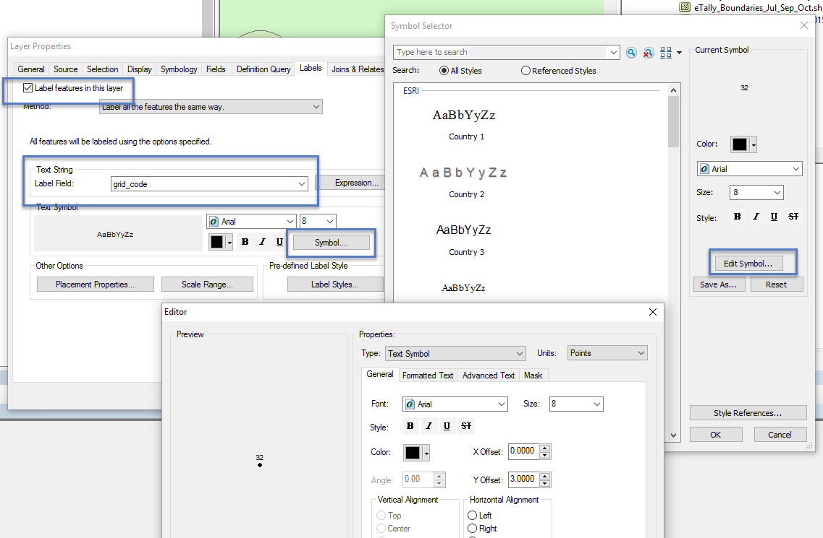

For other layers that you want the label to change with scale, uncheck

